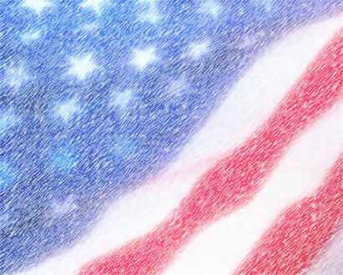
Ms. Chacon’s 7th Grade Civics Syllabus

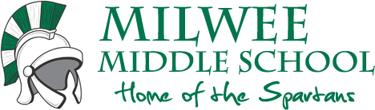
Ms. Yessenia A. Chacon
Milwee Middle School
1341 S. Ronald Reagan Boulevard .
Longwood, Florida 32750
Room: Portable 5
Email: Yessenia_Chacon@scps.k12.fl.us
Website: www.ychacon.weebly.com

Our Course Objectives:
The ultimate goal of this class is to provide students with a well-rounded understanding of how the United States functions as a country. Students will explore the rights and responsibilities of American Citizens and the inner workings of our federal, state and local governments, so to better prepare them for entering a 21st Century United States of America.

What does this mean to me?
This year you will embark in a new journey and I hope you are as excited as I am. I want you all to remember one thing, this class is awesome! This is a very important since one day the 7th grade class of 2013-2014 will run this amazing country. In this class you will begin learning how the United States government is run. The knowledge and skills you acquire in this class will help prepare you to be a working part of a 21st century United States of America. And, because the content of the course is so vital, students will eventually have to demonstrate mastery, by passing an End of Course Exam (EOC), before they can exit to high school.
Take a moment, read that last part over again, and let it sink in...
Okay, now remember the first thing I mentioned: this class is awesome. We will have fun in here and that will help you learn the content, too. We will laugh and yell, and dance and sing. (My dance moves are phenomenal and I apologize ahead of time for the singing.) We will move around and go outside and work with other classes. We will use technology on an almost daily basis. We will joke and play and even occasionally get off topic, but it’s super important that when it’s time to move forward, that we are able to move forward. I need you to show up on time, ready to follow the two policies below. It’s going to be a great year!

Classroom Policies/Supplies:
1. RESPECT YOUR SCHOOL, YOUR PEERS, YOUR TEACHERS, AND YOURSELF
2. COME TO SCHOOL PREPARED TO GIVE YOUR BEST EFFORT
If the student has a cell phone, they should also bring this to class.
(There is a Technology and Cell Phone packet and permission slip and an Edmodo Parent Permission form that outlines this as well.)
Textbooks and Other Resources
Students will work primarily out of McGraw Hill’s Civics, Economics, and Geography textbook and the accompanying My Reflections workbook. Each student will be issued their own workbooks, but these workbooks will remain in the classroom.
Online Resources
Website/Resource | Purpose
www.ychacon.weebly.com | This is our class website and our class backbone! It will be used to outline the weekly schedule, give a listing of all assignments due for the week and direct students on where to find these assignments/how to complete them, etc.
www.edmodo.com | This will be used to submit assignments, take quizzes and tests as well as access some online materials.
McGraw Hill (Textbook)  http://connected.mcgraw-hill.com/ | Civics, Economics and Geography textbook and the accompanying My Reflections workbook are our text-based resources. Students will be issued their own workbooks as well their own web-based login.
Skyward | This website enables parents to access grades and attendance for each individual class. It also, allows parents to access your child’s basic demographic information, including emergency contact.

This is going to be an awesome year! Once you finish reading the syllabus, please head to www.ychacon.weebly.com to complete your syllabus acknowledgment form and technology survey!

